**Lab 02**

**Examples of Arrays**

**1. Program to store and print an array of integers**

#include <iostream>

using namespace std;

int main() {

int arr[5] = {10, 20, 30, 40, 50}; // Declaration and initialization of an array

// Loop to print each element in the array

for (int i = 0; i < 5; i++) {

cout << "Element at index " << i << " : " << arr[i] << endl;

}

return 0;

}

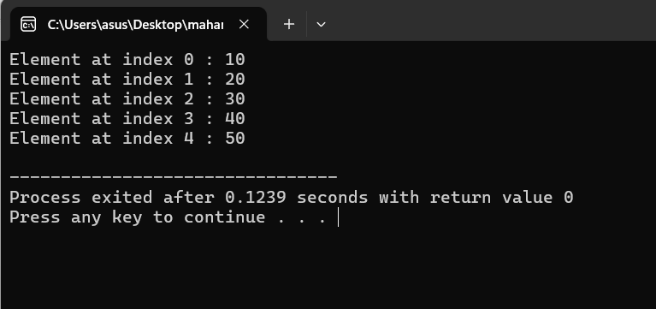

**2. Program to find the sum of all elements in an array**

#include <iostream>

using namespace std;

int main() {

int arr[] = {1, 2, 3, 4, 5};

int sum = 0;

// Loop to calculate sum of array elements

for (int i = 0; i < 5; i++) {

sum += arr[i];

}

cout << "Sum of all elements: " << sum << endl;

return 0;

}

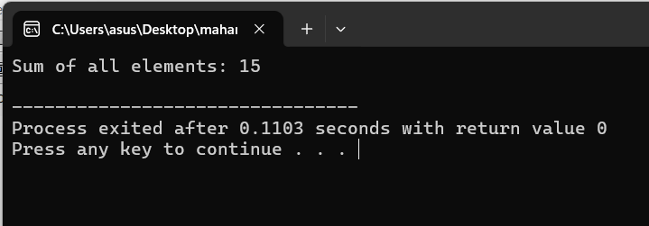

**3. Program to find the largest element in an array**

#include <iostream>

using namespace std;

int main() {

int arr[] = {12, 34, 9, 45, 23};

int max = arr[0]; // Assume first element is the largest

// Loop to find the maximum element

for (int i = 1; i < 5; i++) {

if (arr[i] > max) {

max = arr[i];

}

}

cout << "Largest element in the array: " << max << endl;

return 0;

}

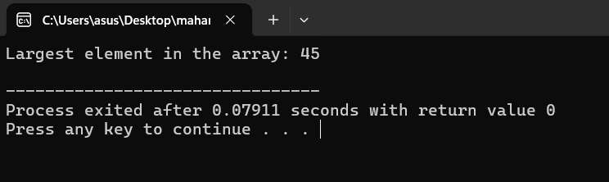

**4. Program to reverse the elements of an array**

#include <iostream>

using namespace std;

int main() {

int arr[] = {10, 20, 30, 40, 50};

int size = sizeof(arr) / sizeof(arr[0]);

cout << "Array in reverse order: ";

// Loop to print array elements in reverse order

for (int i = size - 1; i >= 0; i--) {

cout << arr[i] << " ";

}

cout << endl;

return 0;

}

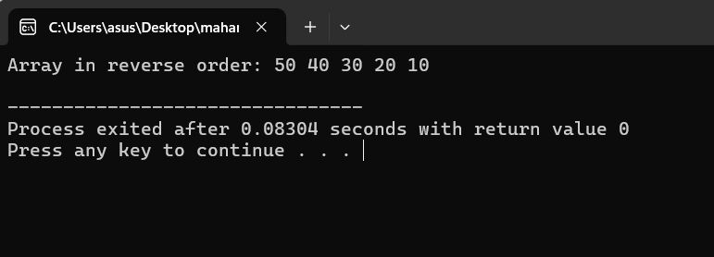

**5. Program to search for an element in an array**

#include <iostream>

using namespace std;

int main() {

int arr[] = {15, 25, 35, 45, 55};

int size = sizeof(arr) / sizeof(arr[0]);

int key, found = 0;

cout << "Enter the element to search: ";

cin >> key;

// Loop to search for the element

for (int i = 0; i < size; i++) {

if (arr[i] == key) {

cout << "Element found at index: " << i << endl;

found = 1;

break;

}

}

if (!found) {

cout << "Element not found in the array" << endl;

}

return 0;

}

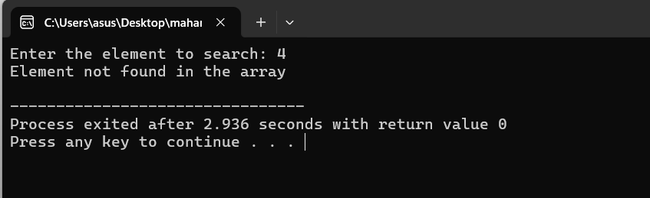

**6. Program to Find the Maximum Element in an Array:**

#include <iostream>

using namespace std;

int main() {

int arr[] = {10, 20, 5, 15, 25};

int max = arr[0];

// Find the maximum element

for (int i = 1; i < 5; i++) {

if (arr[i] > max) {

max = arr[i];

}

}

cout << "Maximum element: " << max << endl;

return 0;

}

